Lab 06 Template – Ethan Roepke

1. **Screenshot of NAT IP address**

(10 points)

1. **Screenshot of success connecting to LDAP server**

(20 points)

1. **Screenshot of created users**

(10 points)

1. **Screenshot of successful authentication as Bill Gates**

(10 points)

1. **Screenshot of output of id command as Bill Gates on workstation**

(10 points)

1. **Screenshot of successful NAT rule**

(20 points)

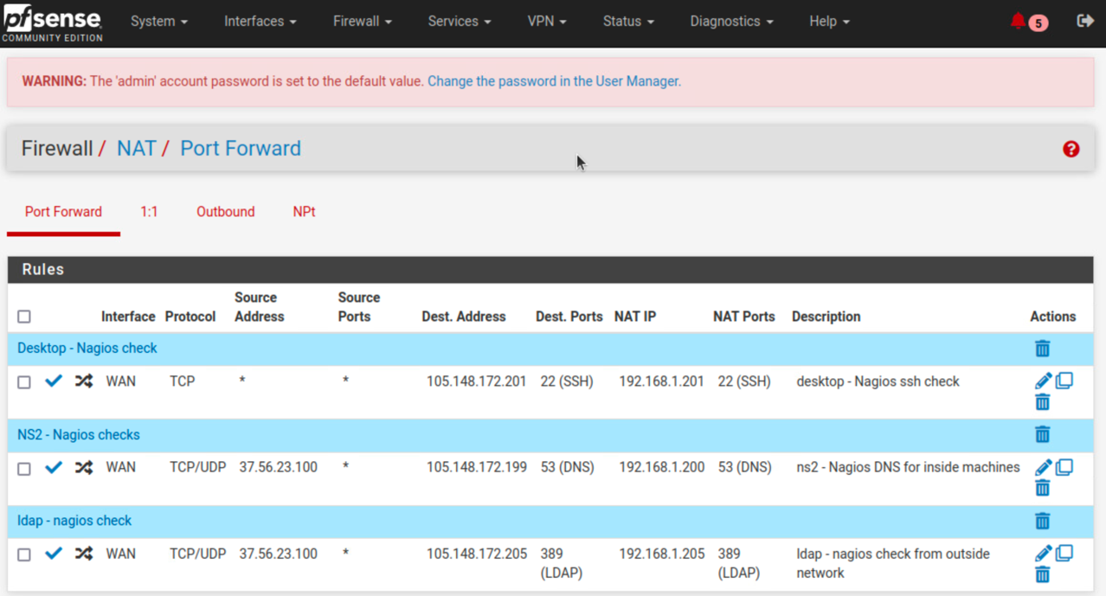

1. **Screenshot of the Nagios query showing green**

(20 points)

